|  |  |  |
| --- | --- | --- |
| **Course : Client Side Web Development (FSD103)** | **Assignment 1** | |
| **Instructor: Kadeem Best** | **Date Given: Sunday, April 12th 2020** | **Date Due: Friday, May 29th 2020** |

**Notes for the Student:** This Assignment is designed to give you practical experience in building client side web applications using Vanilla JavaScript.

**Background**: You will need to have access to a code editor and have a sound understanding of HTML5, CSS3, Vanilla JavaScript and a thorough understanding of Event Driven programming and DOM manipulation.

## Assignment Submission Requirements

* A link to the GitHub repository of your web application.
* A link to your hosted application on Netlify
* A link to your video detailing the demonstration of your game. In the video you must state your name, give an overview of the application, state the technologies used to develop the application and lastly, demo you playing and explaining the functionality of the working application.

## Assignment Regulations

* This assignment must be done individually.
* Must be submitted to Google Classroom at midnight on the deadline date.
* You must demo the working application to the class on Saturday, May 29th 2020.

# **Detailed Specification**

You have been asked to develop an educational **Alien Invasion math game** in the form of a web application. The intent of this game is to test players mathematical acuity on basic arithmetic, specifically addition and subtraction .

A well-designed responsive web interface, similar to the ones presented below must be developed to allow the player to play the game. **Please note, this game must look and function well on both web browsers and mobile devices.** Thus thoroughly test on the aforementioned devices.

**Rules:**

* When the player launches the game, he/she, via buttons, should be allowed to start the game and view the rules of the game. Also, at start up, via some sort of audio icon, the game should give the player the ability to turn off or turn on audio for the game.
* The player should then be allowed to enter their name and then select a difficulty level, i.e, easy or hard.

***Figure 1.1***

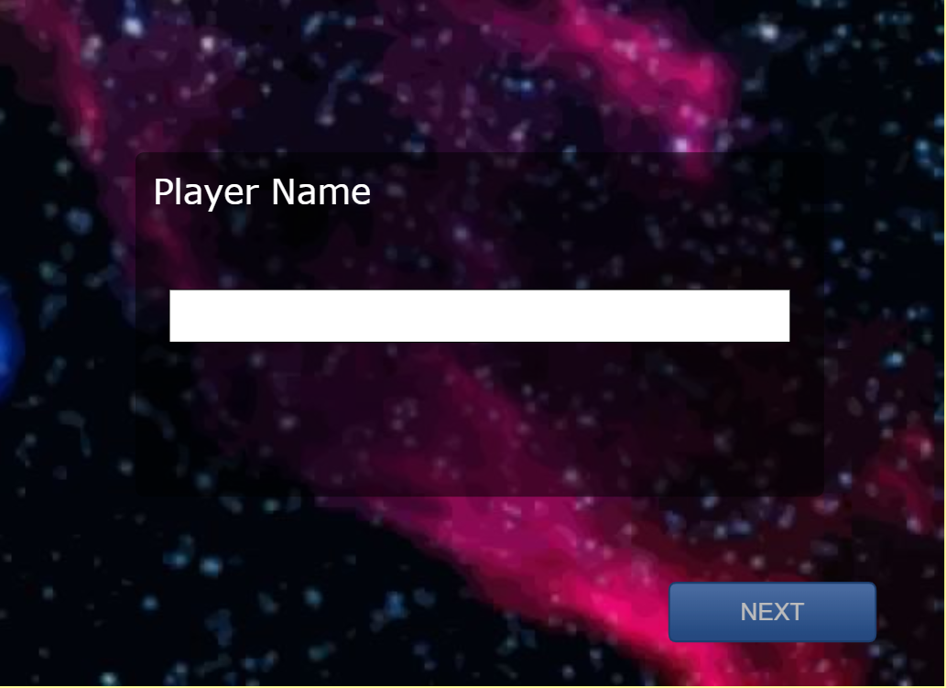

***Figure 1.2***

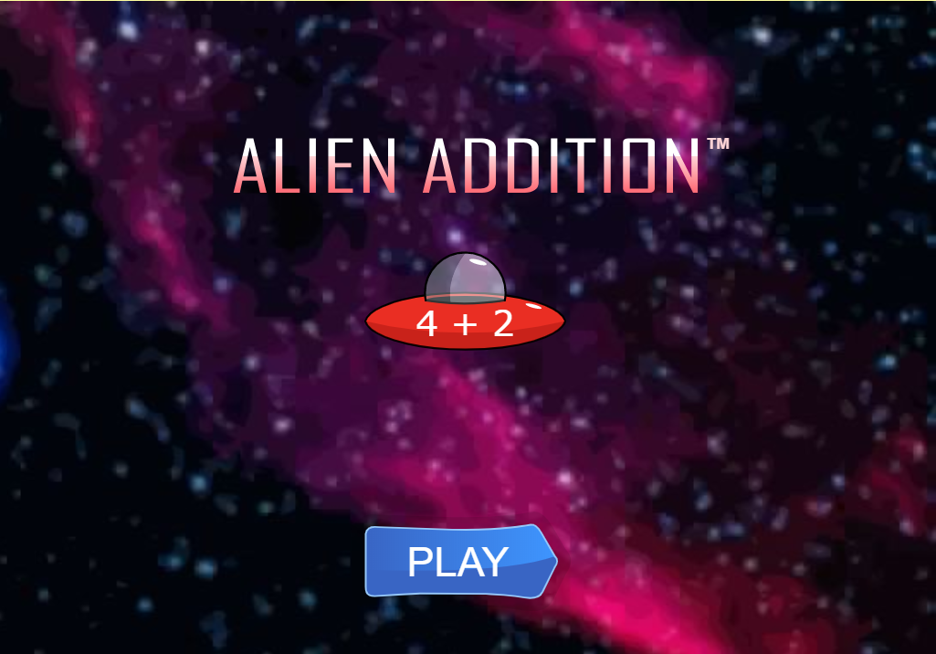

* When the game commences, it should mirror Figure 1.3 - Figure 1.5, invading spaceships with math problems moving (slowly or fast, this depends on the difficulty level) down from the top of the screen toward a laser cannon on a platform at the bottom. Answers are placed “on” the cannon to “destroy” the invader with the correct answer. **Note, each spaceship MUST move at slightly different speeds.**

**Figure 1.3**

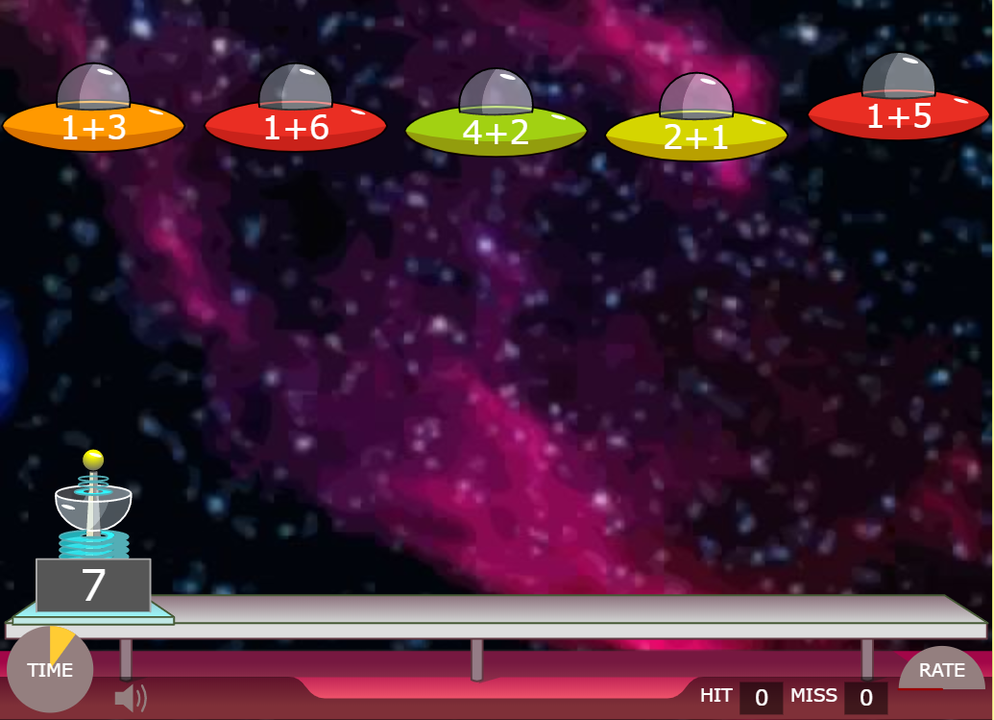

**Figure 1.4**

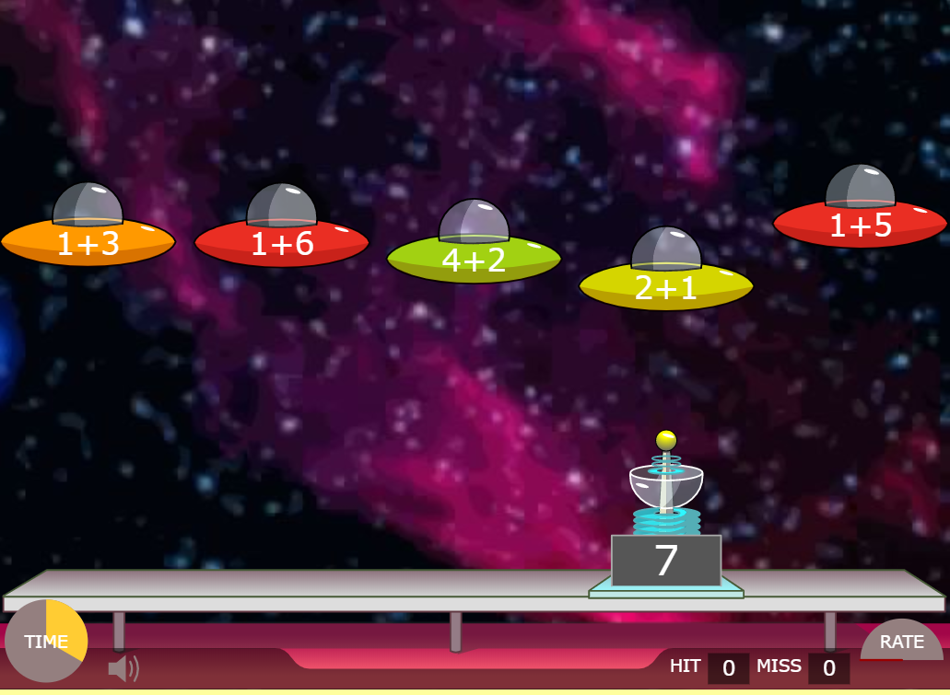

**Figure 1.5**

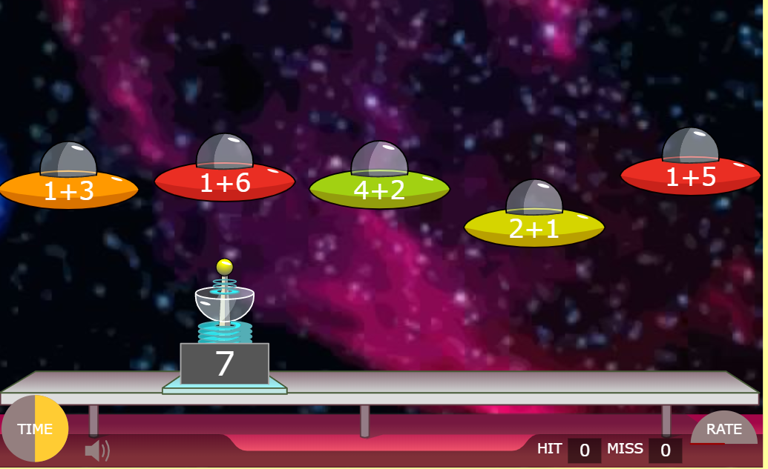

* The aim of the game is to use the cannon to “shoot down” or destroy as many invading spaceships with correct answers, during a particular time frame. This must be done without any of the invading spaceships touching the cannon and/or the plank the cannon is on.
* You must use the left and the right arrow key to move the cannon. Once the cannon is moved or positioned underneath a spaceship then you must use the spacebar key to fire at the spaceship.
* Every time the cannon destroys a correct answer invading spaceship, all the spaceship goes back to the top, new math problems are generated on all spaceships and a new answer is placed on the cannon.
* If the cannon shoots at an incorrect answer invading spaceship, new math problems are generated on all spaceships and a new answer is placed on the cannon. However, the spaceships continue to proceed to touch the cannon and/or plank as at their current position. Under this circumstance, the spaceships do not go back to the top as compared to destroying a correct answer spaceship.
* Please note, at all times, 5 invading spaceships must be present and at any given time, there must only be one correct answer invading spaceship that corresponds to the answer on the cannon.
* Your number of “hits” is increased every time an invading spaceship with the correct answer is destroyed . Whereas, every time an invading spaceship with an incorrect answer is destroyed it will be recorded as a “miss”.
* The player will automatically lose the game if the cannon or plank is touched by an invading spaceship.
* The game consists of 2 levels, level 1 and 2.
* Level 1 is Addition :

**Addition**

This level is deemed as the Addition level. The intention of this level is to test the player’s ability to add basic numbers within 90 seconds**.**

For each math problem/“Invading spaceship”, two random numbers must be generated. The first random generated number must be between 1 to 25 and the second random generated number must be between 1 to 9. The correct answer, which will be written on the cannon, must also be randomly generated.

Once the cannon is not touched and when the 90 seconds is up, the player will automatically move onto level 2.

* Level 2 is Subtraction:

**Subtraction**

This level is deemed as the Subtraction level. The intention of this level is to test the player’s ability to subtract basic numbers within 60 seconds**.**

For each question, “Invading spaceship”, two random numbers must be generated. The first random generated number must be between 1 to 25 and the second random generated number must be between 1 to 9. Note, the first number must be greater than the second number.

Once the cannon is not touched and when the 60 seconds is up, the player will automatically win the game and the player will be presented with a report detailing the following information :

1. Player’s name.
2. Difficulty Level
3. The number of hits the player got for each level. The hits are the questions that the player answered correctly.
4. The number of misses the player had for each level. The misses are the number of questions that the player answered incorrectly.

* The only difference between the Easy difficulty level vs Hard difficulty is speed at which the spaceships are moving towards the cannon. The spaceships must move at a faster rate than with the easy level.

**THE END**